**Severe biological effects due to current ocean acidification conditions in the highly variable fjord-like estuarine regimes of the Puget Sound**

**Introduction**

The comprehensive understanding of oceanographic processes controlling spatial and temporal variations in ocean acidification (OA) conditions in the open ocean and nearshore regions has improved our capacity to identify the drivers, distinguish between natural and anthropogenic signals, and predict future scenarios and trends under climate change scenarios. Especially in the coastal region of the California Current System (CCS), predicted intensification of OA has started to increase in the magnitude, duration and frequency of OA events (Turi et., 2016; Hauri et al., 2015; Chan et al., 2016), with detrimental impacts on the most vulnerable marine communities, such as ecologically and economically important pelagic and benthic calcifiers (Bednarsek et al., 2014; 2016; Bednarsek et al., in revisions; Kapsenberg et al., 2018).

Compared to the coastal systems, estuaries reflect the processes on a regional and local level, characterized by natural fluctuations that vary cross different time and spatial scales. Complex interaction of processes, such as intense respiration, freshwater (riverine) inputs, and other redox reactions, result in seasonally prolonged low pH and aragonite saturation state (Ωar). Furthermore, anthropogenic input as run-offs, wastewater and local CO2 atmospheric depositions, can further intensity the exposure, exacerbating poor acid buffering capacity of the estuaries with increased carbonate dissolution (Cai et al., 2017) and results in rapid shift of the baseline biological thresholds across the species and estuarine communities (Shaw et al., 2013).

Despite high baseline OA vulnerability, current understanding of the biological impact caused by estuarine acidification is still scares, especially the effects of prolonged seasonal exposure and intense Ωar magnitude typical for the estuarine systems.

The Puget Sound is a complex estuarine system in the Pacific Northwest (US) that includes variety of small embayments with secondary estuaries, deltas, rocky shores and beaches. It supports abundant biological, recreational, cultural and economic resources (Ref.). With respect to OA exposure, the system has one of the strongest temporally and spatially variable OA patterns, varying from daily, seasonal (synoptic) and inter-annual scales across various spatial habitats. In the late spring and summer, coastal upwelling makes an important contribution to the delivery of cold, acidic, oxygen-depleted water into the Salish Sea basin (Feely et al., 2010). At the end of the summer, predominant driver shaping carbonate chemistry in the Puget Sound include intense respiration combined with low mixing, intensified freshwater inputs. From the anthropogenic drivers, local eutrophication and atmospheric deposition are the most important contributions to changing OA baseline conditions (Feely et al., 2010, 2012; Bianucci et al., 2015; Pelletier et al., 2017, 2018).

Pteropods are pelagic zooplankton that are seasonally abundant in the Puget Sound, with generation time of 1-1.5 years, and major spawning events occurring in the spring, and a minor in the autumn (Wang et al., 2017). During major recruitment events, they can (along the US West Coast) represent an important food item for ecologically and economically important fish species (find specific references for Puget Sound; otherwise Aydin et al, 2005; Armstrong et al., 2007; 2015). They show sensitive and specific responses to OA through their shell dissolution, endorsing it as one of the first indicators that can be easily implemented for towards progressive OA monitoring (Bednarsek et al., 2017). Along the shell dissolution, OA has been demonstrated to impair majority of pteropod cellular, physiological and organismal responses (Bednarsek et al., metanalyses; submitted). Despite fairly good understanding of their OA responses along the nearby coastal habitats within the California Current System, which are much less vulnerable to OA, nothing is known about the current biological impacts of OA on marine calcifiers in the estuarine system of the Puget Sound.

Contrary to the experimental studies that only allow studying pteropod responses over short time periods (Howes et al., 2014), sampling in the estuarine habitats provides insights into biological responses under prolonged and variable OA exposure. We used pteropod dissolution to track OA exposure across different temporal and spatial scales, effectively capturing the exposure throughout their entire life history to determine the severity of biological impairments due to OA scales in the Puget Sound. We hypothesized that pteropod shell dissolution will be most severe at stations with the highest magnitude and duration of OA stress, taking into the account that the cumulative exposure to OA stress will be integrated within across different life stages.

To established baseline relationship between OA exposure and biological responses (i.e. shell dissolution) of pteropods in the Puget Sound, we investigated the linkage between chemical conditions and biological responses by combining 56 field surveys (7 different time observation since 2014 through 2016 across 8 spatially different locations). We aimed to delineate three following lines of investigations. First, we characterized seasonal and interannual OA exposure across three different estuarine subhabitats inhabited by pteropods. Second, pteropod shell dissolution was linked to the OA exposure to determine the extent of spatial and temporal changes in the biomineralization processes. Third, biological responses were linked to a multitude of other environmental drivers that can simultaneously co-occur across the estuarine habitats, including warming and low dissolved oxygen (DO). The ultimate aim of the study lays the foundation towards providing an assessment of the ecological integrity of the Puget Sound community under intensified OA conditions.

**Methods**

# Observed data

Biological and chemical conditions were sampled at seven sites in the Puget Sound over three years with three sample events per year (April, July, and October, n = 56, Figure 1). Biological samples included XYZ. Chemical conditions were sampled with CTD sensor profiles from the surface to the maximum depth at each station. For each cast, chemical parameters were measured in situ or estimated in the laboratory from Niskin samples collected at each depth. Chemical data included water temperature (C), dissolved oxygen (), pCO (), CO (), pH, salinity (psu), and aragonite saturation state (). For each cast, water chemistry variables were summarized to describe the minimum, average, maximum, and standard deviation of values across the depth profile. These estimates were used to describe the range of conditions that pteropods may be exposed to in the water column at each station.

**Shell preparation and dissolution assessment**

10-20 pteropods were subsampled from the sample and prepared for SEM observations following Bednaršek et al. (2016) protocol. In short, pteropods were in gradual steps transferred from 100% to 70% and 50% ethanol, rinsed thoroughly with DI water and exposed to hydrogen (or sodium hypochorite) for 5 minutes, and rinsed with DI water 2-3 times to completely eliminate it from the shell. To remove the organic layer, 1% KOH solution was used for 2 hours followed by a rinse and dried the samples overnight for 12 hours. Mounted samples were coasted with a combination of Au-Pd for 120 seconds at 35 am before being examined under SEM.

For shell dissolution assessment, we followed Bednaršek et al., (2014, 2016) procedure, counting the organisms with Type I, II and III dissolution, with final unit assessment in # ind with Type I, II, III. For the analyses, we have only used Type III results.

# Site groupings based on environmental conditions

Environmental data at the monitoring sites were evaluated to identify similarities among chemical conditions between sites related to spatial, seasonal, and annual differences that could explain variation in pteropod response measures. Salinity, temperature, oxygen, and aragonite saturation state observations were evaluated to describe variation among sites related to oceanic influences and dominant acidification gradients. Sites were clustered using the average chemical values for each site across years for the same month to identify dominant seasonal patterns. Hierarchical clustering based on the unweighted pair group method and Euclidean dissimilarity measures of standardized variables was used to identify groupings between sites (Hartigan 1975, Oksanen et al. 2018). This produced a dendrogram across the three sample years for each month that was used to identify dominant groupings of sites. Principal components analysis was also used to similarly identify dominant environmental gradients in salinity, pH, temperature, and aragonite saturate state across the stations and sample period (Venable and Ripley 2002).

# Comparisons of pteropod response measures with environmental conditions

Pteropod dissolution rates were compared with environmental data at each site to evaluate associations that could explain differences among the spatial groupings identified through clustering. Because the collected data represented time series of biological and chemical observations, a primary goal of the analysis was to evaluate changes in pteropod response to environmental conditions as a function of the frequency and magnitude of exposure duration to dominant environmental gradients across the sites. For each time series at each site, a variable was defined that described the “cohort-year” to quantify an approximate annual time period from the end of spring spawning to just prior to spring spawning the following year. For example, July 2015, September 2015, and April 2016 were assigned a cohort-year of 2015 to track individuals that hatched in spring 2015 and matured to adults by spring 2016. This variable provided a basis of comparison for exposure of pteropod cohorts throughout their life cycle to seasonal environmental gradients and minimized the comparison of exposure effects across different cohorts. Although secondary spawning events can occur in the Fall, preliminary analyses indicated that cohort years based on spring spawning events had more consistent and interpretable associations with environmental conditions.

For each cohort-year, dissolution rates were compared to environmental conditions using the summarized data from the CTD sensor profiles. Comparisons were made based on visual assessments of trends at each site and from linear regression analyses to quantify associations between dissolution rates and environmental data. Analyses were conducted using combined observations for all sites, as well as separate analyses using observations grouped by month (e.g., April observations across all cohort-years) or by year (e.g., 2015 cohort-year observations across months) to characterize potential seasonal or annual differences. Simple bivariate comparisons were evaluated with linear models (e.g., dissolution vs. saturation state), followed by a comparison of co-occurring stressors on pteropod response measures. The latter analysis followed methods in Bednarsek et al. 2018 to characterize potentially additive or synergistic associations of environmental conditions with dissolution rates. These models were developed to describe dissolution rates relative to main effects for each of two environmental variables and a third term for the interaction between the pair. Models with variance inflation factors greater than ten for pairs of environmental variables were not considered (Zuur et al. 2007, Bednarsek et al. 2018).

The time series observations of pteropod response measures with environmental conditions measured for each cohort-year also provided an opportunity to evaluate cumulative exposure effects, as compared to “snapshot” comparisons of observed environmental conditions with dissolution rates in the regression analyses. An empirical framework was developed that characterized the duration and magnitude of environmental conditions that a cohort was exposed to throughout its lifecycle. For example, individuals exposed to omega saturation states for longer periods of time (duration) that were very under-saturated (magnitude, e.g., ) throughout the cohort-year were expected to have greater dissolution rates expressed in adults at the end of the cohort-year. Dissolution rates may also vary if individuals were exposed to varying duration and/or magnitude of OA conditions, e.g., effects could vary for extremely under-saturated conditions that occurred for a short period of time as compared to slightly under-saturated conditions for a longer period of time. The empirical framework was developed to quantify these differences in exposure:

whereby cumulative stress () for each cohort-year is equal to the duration () and magnitude () of exposure. Explicitly, the duration and magnitude were estimated as the cumulative sum within each cohort-year for which omega was under-saturated.

For each cohort-year at each station, was estimated as the cumulative sum across the months for the observed omega saturation state minus a critical threshold defined as under-saturated. The critical threshold for aragonite saturation state was fixed at , although the approach is flexible and different values could be tested to explore associations with pteropod response measures.

**Relating life history and recruitment patterns with the environmental variability**

For accurate interpretation of interannual variability of the shell dissolution, we incorporated pteropod cohort-related life history within the collected samples and compared it with previously published study on pteropod life history form Wang et al. (2017). We observed larval and juveniles (G2 cohort) present in spring and fall samples, and to a lesser extent in the summer time. This indicates two strong spawning peaks in the spring and fall, and likely continuous spawning in between. From the spring to late summer, G2 grows very quickly to adults (G) and experiences the highest Ωar values. G cohort spawns (G2) and subsequently dies off, living for half of a year. The fall cohort (G2) continues growing throughout the winter to adults (G) in the spring during the winter Ωar, ave <1 conditions. G spawns in early spring, with the spawning co-inciding with the increase of Ωar after the spring bloom. This cohort lives for approx. 9 months.

**Results**

*1 Characterization of temporal and spatial carbonate chemistry variability in the Puget Sound*

Investigated stations around the Puget Sound (Figures 1, 2) shows characteristic patterns in carbonate chemistry exposure that can have profound impact on the biological responses. Because the interannual variability is consistently smaller than seasonal, the analyses only focus on the seasonal effect. Cluster analyses based on the primary oceanic and carbonate chemistry variables (salinity, temperature, oxygen, and aragonite saturation state) for each month provided a consistent separation of sites into three groups (Figure 2). Station 22 was consistently shown as an outlier, whereas stations 4, 12, and 402 and stations 8, 28, and 38 were characterized as having similar environmental variables within each group for each season. A minor exception to this overall pattern was observed in April when station 28 was more similar to station 22. Overall, similarity across seasonal variability between the stations provided the baseline of spatial habitat characterization that was further use towards evaluating biological responses.

The general site groupings in Figure 2 were also supported by results from a PCA (Figure 3). Observations across months and sample years explained 50% in the first axis and 27% in the second axis of the variance among salinity, temperature, oxygen, and aragonite saturation state at the sample sites. The first axis explained a gradient between oxygen and aragonite saturation state that was opposed with water temperature (Figure 3, left plot). The second axis primarily described a salinity gradient with negative loadings on the axis described by higher salinity. As such, observations for station 22 that was located closer to the Salish Sea (Figure 1) were more closely associated with the salinity vector (group 1). Observations for group 2 (stations 8, 38, 28) were associated with the oxygen and aragonite saturation state vectors and observations for group 3 (stations 4, 12, 402) were associated with the temperature vector (Figure 3, right plot). The site points in Figure 3 (left plot) were also sized by type III dissolution of pteropods and a general pattern of greater dissolution was associated with positive values on the second principal component axis and negative values for the first principal component axis.

The largest temporal and spatial variability in the environmental conditions is observed in carbonate chemistry parameters. To be able to relate chemical conditions to biological responses, we are focusing on Ωar as the most sensitive OA parameter. The most conspicuous variation was recorded in the minimum omega saturation state (Ωar,min) within the upper 100 m water column, with observed duration ranging from at the seasonal to annual scale. As a general trend, organisms are exposed to late spring- summer supersaturation (Ωar >1) that transitions into undersaturation into the early fall and last until the following spring. However, temporal variability is different when Ωar,min is considered, with the transition to the supersaturated no occurring in late spring, but summer.

The magnitude and duration of this pattern is spatially specific. Stations significantly differed in their Ωar, min exposure across seasonal scales, ranging from short Ωar, min (only in the fall) to medium (across several seasonal) and severe Ωar, min (annual) exposure. Graphic representations of environmental variability in Ωar,min observed at each time interval are shown in Figure 4, respectively. The three station groups defined in Figures 2 and 3 were used for the interpretation of biological responses. Based on the duration of the Ωar, min, we can determine the extent of organismal exposure to the most unfavorable exposure to Ωar, min.

With respect to spatial variability, prolonged shallower embayments (Hood Canal and South Sound Bay) show seasonally distinct patterns in Ωar, min exposure compared to the statins with strong vertically mixing in the Central Basin. Based on the clustering, there are three different patterns of subhabitats with specific magnitude of seasonal evolution ofΩar,min.

1) In the habitat with strong vertical mixing (‘mild exposure subhabitat’ ,#22), the variability is minimal, with the magnitude of the conditionsrounding around near-saturation (Ωar) on a seasonal to annual basis (Figure 4). The organisms at these station experience short duration to Ωar,min <1 during the intense autumn respiration conditions, with Ωar,min not reaching lower than 0.75. Although these conditions might extent into winter period before the conditions improve in the early spring, these kinds of habitats are characterized by mild severity of exposure and subsequent low biological impacts.

2) Semi-enclosed habitats are characterized by larger variability in the Ωar (‘moderate exposure subhabitat, #8, #28, #38), with the lowest Ωar,min magnitude occurring in the spring- summer and winter transition. These habitats are characterized by seasonal exposure to Ωar,min <1 staring in the early fall, whereby their prolonged duration contributed to the moderately severity of exposure.

3) Seasonally strongly stratified habitats (‘severe exposure subhabitat’, #4, #12, #402) characterized by extended duration and magnitude of very low Ωar,min conditions (down to Ωar ~0.5), but with lower variability of the Ωar exposure. These conditions occasionally occur already during the summer period throughout the winter and can be characterized by severe exposure.

*2 Characterization of variability of DO and temperature in the Puget Sound*

To determine which other (than OA) drivers impact biological response in the estuarine sub-habitats, we examined the effect of increased temperature (T) and low dissolved oxygen (DO) and their interaction with Ωar. Relatively narrow temperature averages vary between 10 and 13 C from spring to the fall, with the spring and fall showing more uniform temperature patterns while summer increases are most evident in the prolonged seasonally stratified embayment. There is no significant correlation between warming and Ωar,min in the system either on a seasonal or interannual basis (p > 0.05). Temporal variation in the salinity range between 27 and 31 is the greatest in the long embayments, while no seasonal variability evident in the central well-mixed areas.

Oxygen concentration varies strongly across the seasons. Throughout most of the season, oxygen is correlated with Ωar (i.e., positive loading on axis 1, Figure 3). Similar correlations were observed within each month, although variance inflation factors were sufficiently low (less than 10) to allow an exploration of combined effects of saturation state and oxygen concentration on dissolution rates (Zuur et al. 2007, Bednarsek et al. 2018). Linear models that evaluated the additive and interactive effects of oxygen and saturation state suggested that oxygen concentrations have a mitigating effect on dissolution rates in undersaturated conditions (Figure 6).

The first model evaluated the association of dissolution with averaged dissolved oxygen concentration in the water column and the percentage of depth samples in each CTD cast that were undersaturated. A significant positive association of dissolution with undersaturation was observed, in addition to a negative interaction between oxygen concentration and percent undersaturation. This suggests that increases in oxygen have a dampening effect on the positive association between undersaturation and dissolution, as shown by the decrease in slope for the model estimates at higher oxygen (blue line, top plot, Figure 6).

Similarly, a second model evaluated the association of dissolution with average dissolved oxygen concentration in the water column and the range of observed aragonite saturation estimates at a site on each sample date. The second model showed a significant positive association between dissolution and aragonite range and a significant negative association between dissolution and oxygen concentration, i.e., overall dissolution increases with undersaturation but the combined dissolution is lower at higher oxygen concentration (blue line, bottom plot, Figure 6). Although the first and second models provide slightly different indications of the co-occurring effects of saturation state and oxygen (i.e., interaction vs additive effects), both suggest a mitigating effect of higher oxygen on dissolution rates for organisms in under-saturated conditions.

*3 Temporal and spatial variability of pteropod shell dissolution*

Pteropods shell dissolution ranges from the surface (Type I) to deeper-protruding (Type III dissolution) that appears randomly throughout the entire shell. Contrary to Type I dissolution, which is transient and can either be repaired or turned into Type III dissolution upon more extreme or prolonged exposure, Type III dissolution is a cumulative exposure marker.

The best correlations between Type III shell dissolution were obtained with Ωar, min, across all the temporal scales, from seasonal to interannual (Figure 4). The averageΩar did not explain seasonal or interannual shell dissolution patterns, often resulting in the opposite trends. This is especially prominent in the spring time where surface- to-subsurface Ωar condition improve but dissolution continues to increase because of organismal exposure to Ωar ,min in the deeper waters during their diurnal vertical migration.

Pteropod shell dissolution (Type III) varied substantially depending on the severity of exposure (Figure 4, right plot) characteristic for specific subhabitats. As such, spatial patterns of variability were more pronounced on shell dissolution than their temporal exposure. Across the subhabitats, shell dissolution (Type III) was the lowest in the late spring and summer, except in the ‘severe exposure subhabitats’ with the lowest Ωar, min and hence most severe exposure (#4, 12, 402). The severity of dissolution increased towards the fall at all stations except if there was a secondary spawning in the fall whereby newly-hatched larvae were not sufficiently long exposed to Ωar, min to demonstrate shell dissolution (st #402, #12, #4) that occurred mostly at the most severely affected stations. The greatest severity of dissolution was observed in the spring at the majority of the stations (Figure 4, left plot, Figure 5, April panel) because of the extended winter-early spring Ωar, min <1 that affected earlier stages of pteropods.

In terms of spatial variability of dissolution patterns, the magnitude difference in the Ωar,min<1 best explains the amount of Type III dissolution (stats, Figure x). The ‘mild exposure subhabitats’, predominantly characterized by Ωar,min ~1 or Ωar,min<1 on a shorter time base (#8 and #22) induced mild shell dissolution, setting up the threshold for mild dissolution around Ωar =1.5. Inital dissolution of the earliest life stage slightly increased to up to 35% individuals affected by Type III in April, demonstrating the exposure to Ωar,min during the fall and into winter before the spring bloom.

Pteropods under ‘moderate exposure subhabitat’ to Ωar,min<1 (#28 and #38) experienced only slight decrease in dissolution compared to the severely exposed stations (#4, #12, #402), where up to 80% of all investigated individuals were are affected by severe (Type III) dissolution in the Sept-April period. Severe magnitude of Ωar,min<1 for a few week duration shows severe dissolution around the thresholds of Ωar = 1 (insert stats on significance – maybe temporal?)

4 *Interannual and seasonal effects of* Ωar,min and other environmental patterns on pteropod shell dissolution

Both, seasonal and interannual trends (Figure 5) demonstrate that Ωar,min to be the main driver behind the uniform patterns of severity of pteropod shell dissolution. Despite strong spatial and temporal variability among the stations, seasonal evolution of the pteropod shell dissolution againstΩar,min demonstrate uniform patterns regardless of the year examined. For the three years of observations (2014-2016), the correlation between Ωar,min and Type III dissolution is comparable and not significantly different (slope estimate of dissolution against saturation state of approximately -0.40, p < 0.05, no year or month effects). The similarity of the shell dissolution between the years are indicative pteropod shell dissolution to be a conservative marker of cumulative exposure to Ωar,min that is not subjected to the annual variability.

The statistical analyses demonstrated that temperature did not have a significant impact on the shell dissolution neither seasonally nor interannually (stat test). Conversely, lower DO (when decoupled from Ωar) induced increased, although (not statistically significant?) amount of dissolution in the early spring. Later in the year, under interactive effects of Ωar:DO as two co-occurring drivers, a synergistic effect of increased occurred (Figure X, stats?)

5 *Life stage related shell dissolution*

We have observed larval stages to be significantly more impacted by dissolution in comparison with the adults (Figure – goes into supplemental). The greatest difference is observed in the spring time, when overwintering adults that were exposed to prolonged Ωar,min conditions show much less dissolution compared to newly hatched juveniles in the spring time exposed to Ωar,min  for a short duration of only a few weeks up to a month time. During the spring-fall transition, the comparative dissolution extents between adults and juveniles are less dissimilar, although still observable.

This indicates potential repair mechanisms that are occurring during the winter-spring period in adults – goes into discussion. Need data for winter

6 *Evaluating temporal and spatial shell dissolution due to cumulative Ωar,min. exposure*

The ‘cumulative stress’ was defined as a combination of magnitude and duration at which the greatest Type III dissolution occurred within a cohort year (equation 2, Figure 7). The magnitude of cumulative stress exposure was strongly correlated with the Type III dissolution with the cumulative stress either increasing (e.g., stations 12, 402, top plot, Figure 7), or remaining unchanged throughout the season from July to next April (e.g., station 8, top plot, Figure 7). As a general pattern, cumulative stress showed increased cumulative stress throughout the time period, with organisms experiencing the lowest stress severity in the summer (level 0) which increases to Sept to stress estimates greater than 1 and April with some stress estimates close to 2 (e.g., stations 12, 402). Significant associations were observed between the cumulative stress magnitude and amount of type III dissolution for the 2014 and 2015 cohort years (linear model p = 0.046, R2 = 0.19, p < 0.001, R2 = 0.48, respectively). The 2016 model was not significant likely due to April observations missing for the cohort year.

**Discussion**

Biological impacts of estuarine acidification on pelagic calcifiers has so far been neglected because of the expectations that estuarine species are well adjusted to the variable conditions with extreme Ωar<1 compared to the open ocean species that are less frequently exposure to such extremes predicted to occur only within the next-decades (Ref.) This study is, to our knowledge, the first that demonstrates biological impacts on pteropods under current in situ estuarine acidification under wide range of spatial and temporal variability, with magnitude and duration exposure not comparable to the coastal systems. This results in significant negative effects in pteropod shell dissolution and likely recruitment patterns.

Under much less severe magnitude and duration of exposure, pteropod have demonstrated increased in oxidative stress biomarker potentially resulting in the loss of lipid reserves and structural damage (Bednarsek et al., 2018), and reduced survival (Lischka et al., 2011; Bednarsek et al., 2017). Bednarsek et al. (submitted) has recently proposed several physiological thresholds for pteropdos that are related to the magnitude and duration of exposure. Given the magnitude and duration of OA conditions in the Puget Sounds, dissolution and recruitment thresholds (Bednarsek et al, submitted) are already crossed in major part of the system (Pelletier, pers comm.).

Future climate change and nutrient related loading will intensify these detrimental biological effects in the Puget Sound that is changing rapidly under combined anthropogenic input (who to reference, which regions the most?).

Our study recognized different type of stations with different combination of magnitude and duration conditions, ranging from mild to severe exposure. Varity of observed patterns in the Puget Sound could be used to characterize different types of diverse estuaries. Since the similarity of physical-chemical processes among estuarine systems, we build on the premise that understanding of coupled bio-chem monitoring in the Puget Sound could be used as a ‘indicator’ for various estuarine regimes in the near-future. Given the severity effects observed in this study we strongly recommend coupled chemical-biological OA monitoring efforts in the estuarine systems. IN addition, pteropods as indicators are representative for ecological integrity (Bednarsek et al., 2017), most notably for the other groups of pelagic calcifiers, such as larval oysters, mussels etc, with similar physiological thresholds and life history (Waldbusser et al., 2014; 2018).

The variability in addressing current and future species responses due to estuarine acidification is still in its infancies. Sensitive shell dissolution is an indicator that is tracking OA exposure in a cumulative way and is such, suitable for monitoring of biological responses in estuarine habitats characterized by not only prolonged duration of the exposure but predominantly by the timing of the exposure that can represent potential population bottleneck. IN terms of biological vulnerability, the most critical component is the timing of the larval recruitment. Based on the observed presence of the larval stages in the samples, we investigated larval recruitment patterns that occurs after the prolonged winter undersaturation that can, in most of the Puget Sound last up until the mid April (Wang et al., 2017). The expectation to this are severely exposed habitats (#402) that encounters bloom in Febr or March (Pelletier, pers. comm.) that quickly changes the carbonate chemistry conditions and can induce subsequent spawning. Indeed, earlier larval recruitments was observed at the stations with earlier phytoplankton bloom developments and subsequent increase in Ωar, compared to the stations with late bloom in which recruitment was delayed.

However, if the bloom is delayed or not as strong to significantly change the condition, our data show that the larval recruitment would still start despite the unfavorable conditions. In such way, the larvae with the thinner shells and the periostracum in the early development, will be exposed to the most corrosive conditions that results in the highest extent of dissolution. Since we observe significantly less dissolution in the summer compared to the spring period, the most dissolved larvae most likely die, the same phenomena observed in larval mussels under undersaturated conditions (Green et al., 2009). As such, only the least affected continue into the summer or are alternatively advected within the system from a less OA affected areas where larvae were not exposed to such degree of dissolution. Later in the summer, carbonate chemistry conditions are already supersaturated so the larval vulnerability associated with the secondary, fall spawning is not as problematic. Following, the timing of the spring transition is the most critical stage for the calcifiers in the Puget Sound and future changes in the carbonate chemistry should focus predominantly on this period since the future anthropogenic inputs will accesserbate the timing of the transition into the supersaturation. T*he most affected regions with this respect will be in the South Sound (what is this area) and the Central Basin (Pelletier, ??, can I reference any already published stuff?), the areas with already delayed phytoplankton blooms (how to best validate this statement>?). What about the changes related to the pre-industrial period?*

Despite high variability of other co-occurring environmental parameters, carbonate chemistry is the predominant driver of the biological responses related to biomineralization and recruitment processes. Despite the great differences in the environmental conditions due to the Blob between years 2014 to 2016, we found strong uniform patterns. The higher temperature impact was not observed in lesser extent and severity of shell dissolution which is different from what was reported for the open ocean (Bednarsek et al., 2018) where the temperature gradients were steeper with much higher temperature extremes. On the other hand, increased temperature most likely caused stronger spawning peak in fall of 2015, which is usually minor in contributing to the overall abundance. Considering the range of seasonal and spatial differences in salinity, we did not see any impact of salinity on the observed patterns. *Comment on oxygen?*

In regards to the spatial connectivity, it has been speculated if pteropods can actually retain in the system with such profound winter undersaturation. Since secondary spawning happens in the late summer, it is less vulnerable subadults or even early stages of adults that overwinter. The fact that early life stages in the spring period are found dissolved in our samples confirms that the majority of the overwintering is happening in the Puget Sound. This points towards certain resilience of pteropod population that has so far not been described or explained and supports the hypothesis that estuarine species may provide present-day insight into the physiological and ecological foundation of OA tolerance. This could only happen with certain adaptation strategies that we will discuss in more depth.

From the fall samples, we have seen sufficient level of variability in shell dissolution of the subadults recognizing that some of the pteropods might be less sensitive compared to the other individuals in the population. Following the fall variability, we found overwintering adults in the spring sample to have mostly preserved shell despite long undersaturation expected to induce severe shell damages. We assume that severely affected organism in the fall would be subjected to mortality and only the ones with minor dissolution or intact shell would be able to go through the winter. Opposite to Wang et al. (2017) estimates of the absence of growth in the more Northern Salish Sea region, we found growth during the winter period, which alludes to metabolically active organisms that could potentially be able to repair their shells to a certain extent, also energetic expense of such activity over longer periods of time is known (Peck et al., 2018). It is however very unlikely that organisms with such profound fall dissolution, which occasionally results in the shell holes, would be capable of such significant repair during the winter.

For the remaining, intact or organisms affected by minor extent, the first strategy of avoiding dissolution includes migration to the upper surface waters supersaturated within the upper 50 m, and near-saturated in the upper 20 m in the most severely affected subhabitats (Pelletier, pers comm). Upper surface water is preferred habitat also given oxygen concentrations, the lack of which could otherwise more severely affect shell dissolution (Bednarsek et al., 2018). The transfer with advection of intact adults from other OA sweetspots is possible but not very likely given that we have found larval organisms at the same stations severely affected by dissolution.

Second adaptation strategy of pteropods in the estuarine regime include the modulation of their life history. We have observed that pteropod can induce the primary spawning earlier in the season after the intense bloom. This is necessary given that egg production can be detrimentally affected by low omega (Manno et al., 2018; Bednarsek et al., 2018). However, in such a way they are to ‘squeeze’ additional spawning processes later in the year. With earlier spawning, the organism will mature earlier under more favorable and can have prolonged secondary spawning, assuring the sustainability of the population.

Third strategy is the presence of genetically different subspecies with potential different degree of resilience. We have found *Limacina helicina helicina* and *Limacina helicina pacifica* to be both inhabiting winter habitats.Although we have not quantitatively evaluated their presence, our preliminary data indicates that *Limacina helicina helicina* with more strongly-built shell might be more resilient and inhabits the most severely affected habitats. It is worth noting that regardless of the species, we have observed thick periostracum in both species that might importantly contribute to preservation of the shell during prolonged exposure. However, phylogenetic characterization of these species is missing making it impossible to link genetic variation to fitness related traits that renders different extents of resilience.

Forth adaption strategy includes building less dense shells. Our uCT analyses on preliminary number of sample indicates that maturing organisms during fall or winter build significantly less dense shell. In the presence of higher concentration of protons in the habitat, this is energetically favorable process, preserving the energy for other vital biological processes.

Overall, the sum of potential adaptation strategies supports the hypothesis that estuarine life history and biomineralization modulations may play a critical role in determining sensitivity of pteropods to OA in the estuarine habitats.

Finally, from the policy perspective, OA in the Puget Sound is regulated under the authority of the Clean Water Act. Even where regulators have tried to apply CWA to address acidification, they have been confronted by a lack of baseline data, an inability to specifically identify sources within their jurisdiction, and the fact that existing water quality standards do not capture the impairments that are associated with ocean acidification (Cooley, 2015: Boehm et al., 2015). Our study identifies that the current estuarine conditions are harmful to organisms, solidifying the base to find the solution tailed to fit unique coastal and estuarine characteristics (Brodeu and Cai). Such strategies of mitigation and adaptation (e.g., nutrient and air pollution management), and thus the science needed to inform them, may differ between specific places because of spatial variation in the mechanisms of acidification and effects on stakeholders. *I need to develop the last paragraph in more details, don’t pay attention.*

**References**

Bednarsek, N., Feely, R.A., Beck, M.W., Glippa, O., Kanerva, M., Engstrom-Ost, J. 2018. El Nino-related thermal stress coupled with upwelling-related ocean acidification negatively impacts cellular to population-level responses in pteropods along the California Current system with implications for increased bioenergetic costs. Frontiers in Marine Science. 5(486):1-17.

Hartigan, J.A. 1975. Clustering Algorithms. New York: Wiley.

Oksanen, J., Blanchet, F.G., Friendly, M., Kindt, R., Legendre, P., McGlinn, D., Minchin, P.R., O’Hara, R.B., Simpson, G.L., Solymos, P., Henry, H., Stevens, H., Szoecs, E., Wagner, H. 2018. vegan: Community Ecology Package. R package version 2.5-2. <https://CRAN.R-project.org/package=vegan>

Venables, W.N., Ripley, B.D. 2002. Modern Applied Statistics with S, Springer-Verlag.

Zuur, A.F., Ieno, E.N., Smith, G.M. 2007. Analysing Ecological Data. New York: Springer.

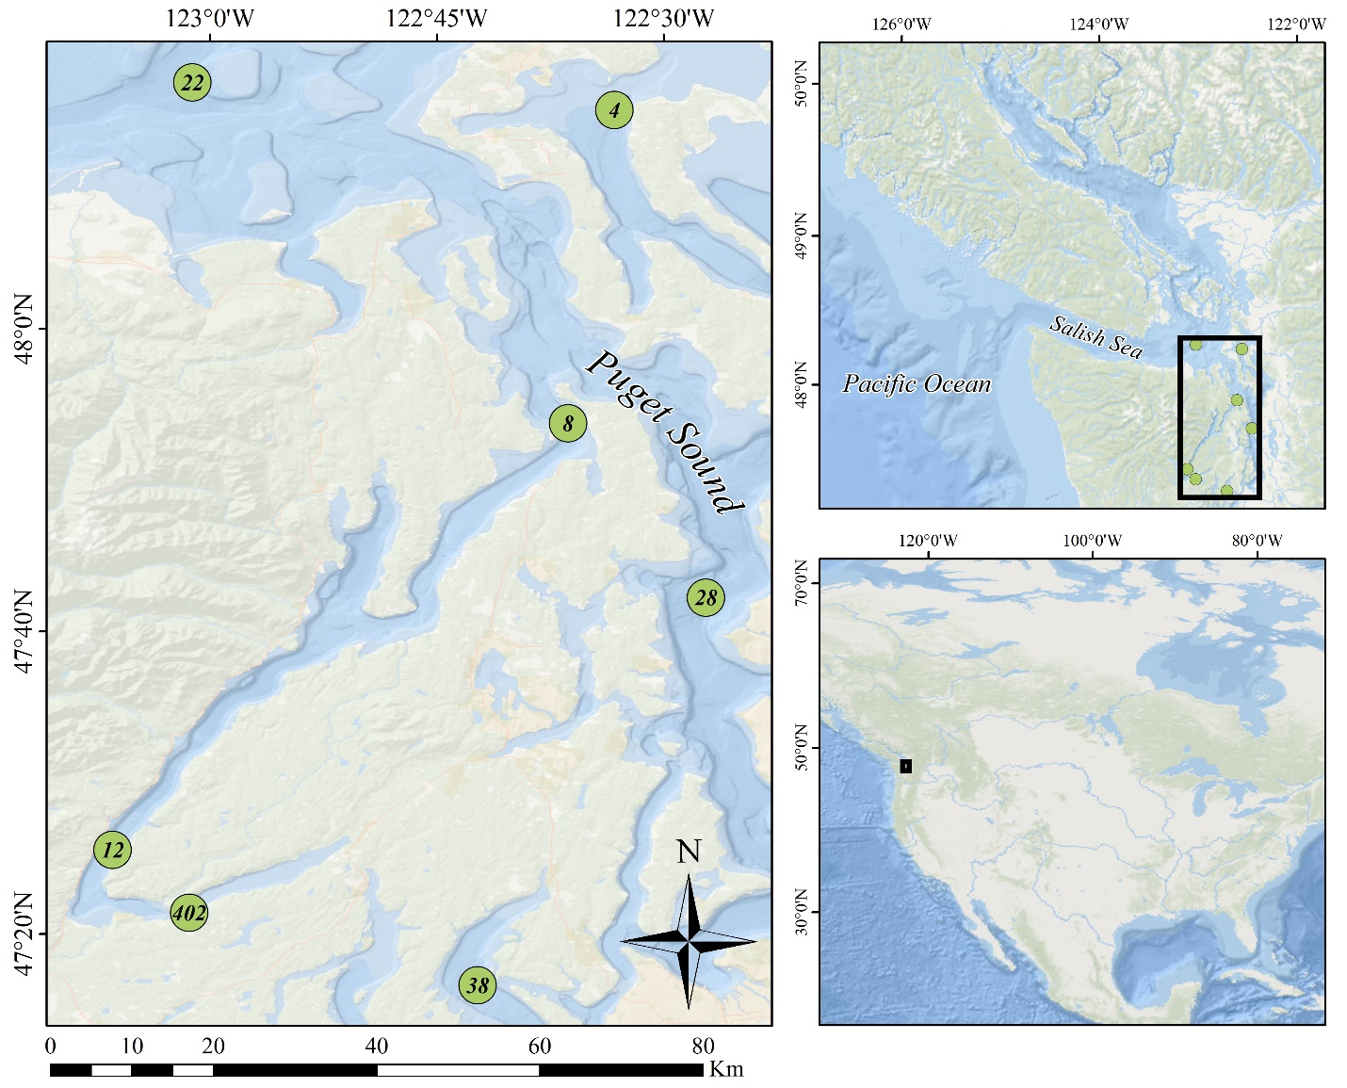

Figure 1: Locations of stations in the Puget Sound where pteropod and environmental sampling occurred. Samples were collected in April, July, and September from 2014 to 2016.

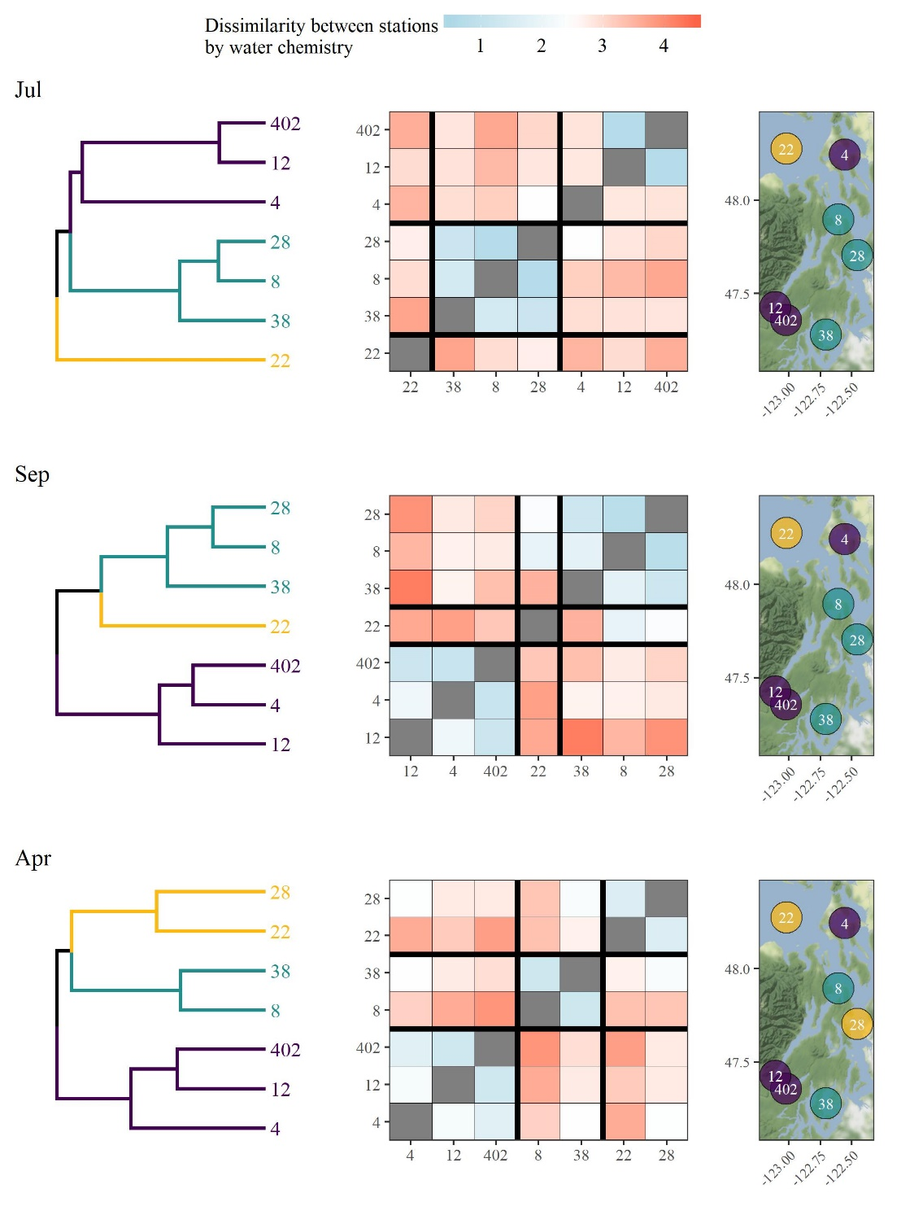

Figure 2: Clustering results of stations based on within-month averages for salinity, water temperature, dissolved oxygen, and aragonite saturation state. Within-month averages are based on all environmental data collected across the sample years from 2014 to 2016 in the same month. Results for each month (starting in July the prior year coinciding with spring spawning) are shown as dendrograms for site clustering (left), dissimilarity matrices showing mean Euclidean distances between observations at pairs of sites (middle), and spatial arrangements of the defined clusters (right). Cluster groups were set at three based on approximate dendrogram separation between sites to explain dominant patterns among environmental variables.

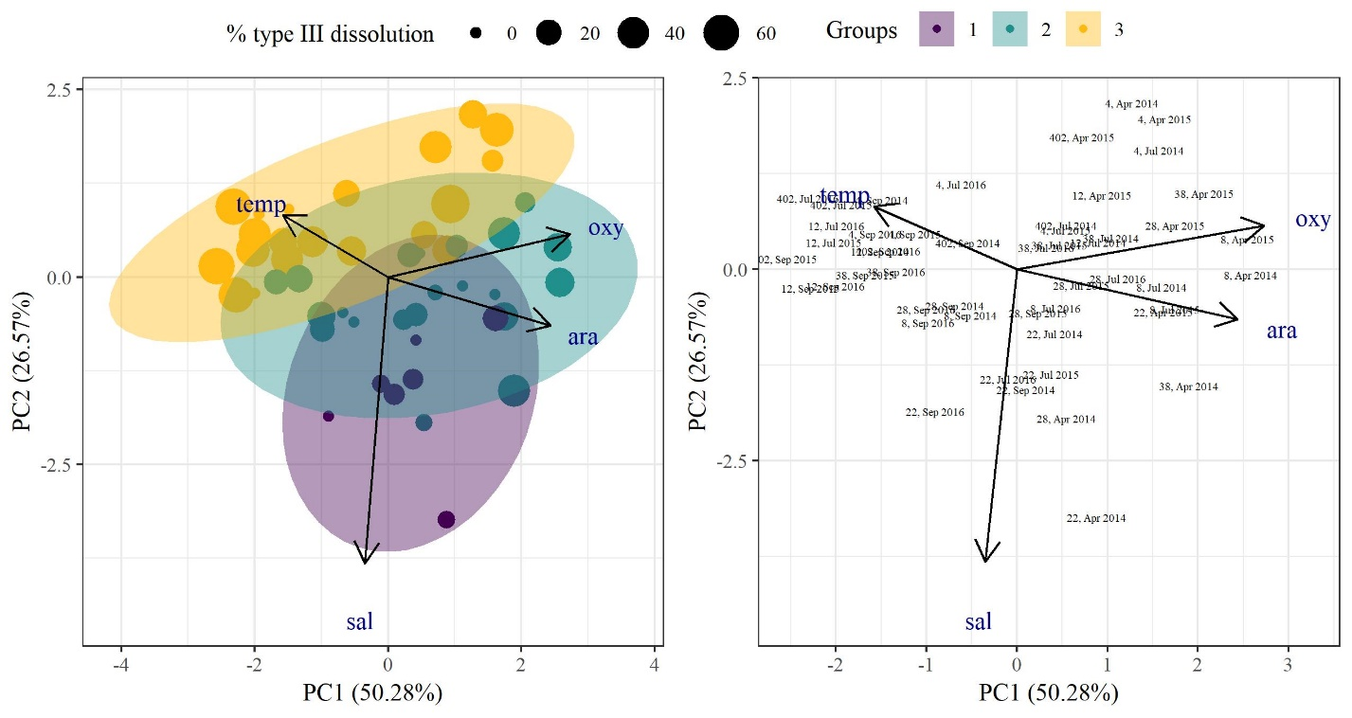

Figure 3: Results of principal components analysis for environmental variables collected at each site for each sample date. Environmental variables included temperature, salinity, dissolved oxygen, and aragonite saturation state. The left plot shows site groupings based on dominant clusters shown in Figure 2, with site points sized by measured type III dissolution for pteropods collected at the same location and date. The right plot shows the sites with text identifiers for the site number, followed by the month and sample year.

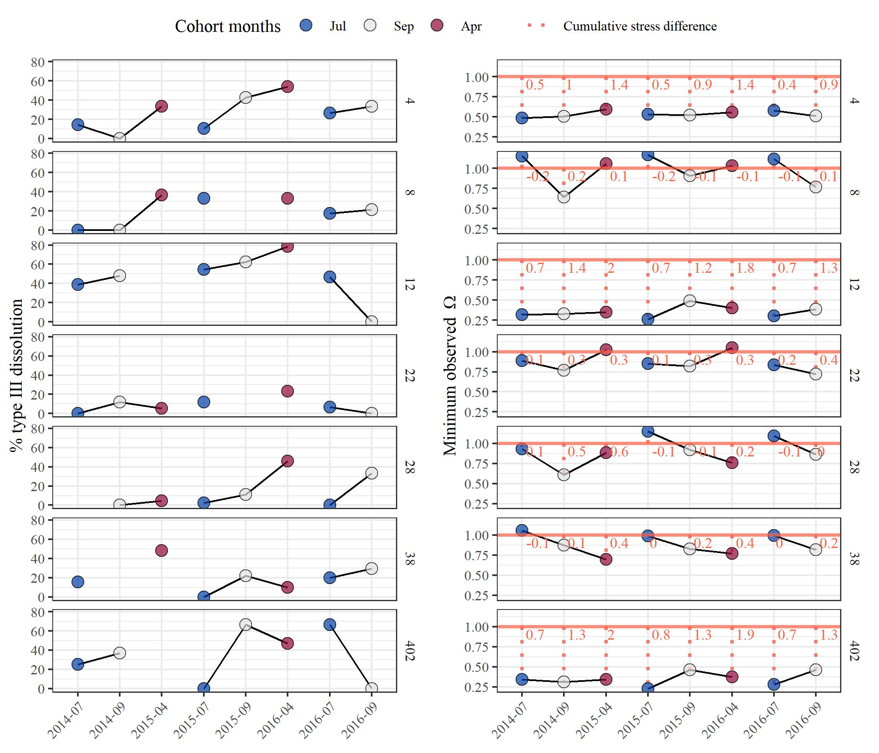

Figure 4: Observed time series for each station (rows) showing % type III dissolution of pteropods (left) and observed minimum aragonite saturation state (right). Points at each station are connected by cohort years. The right plot shows the selected aragonite threshold () as a horizontal line with the difference between the threshold and minimum observed value shown as a dotted line.

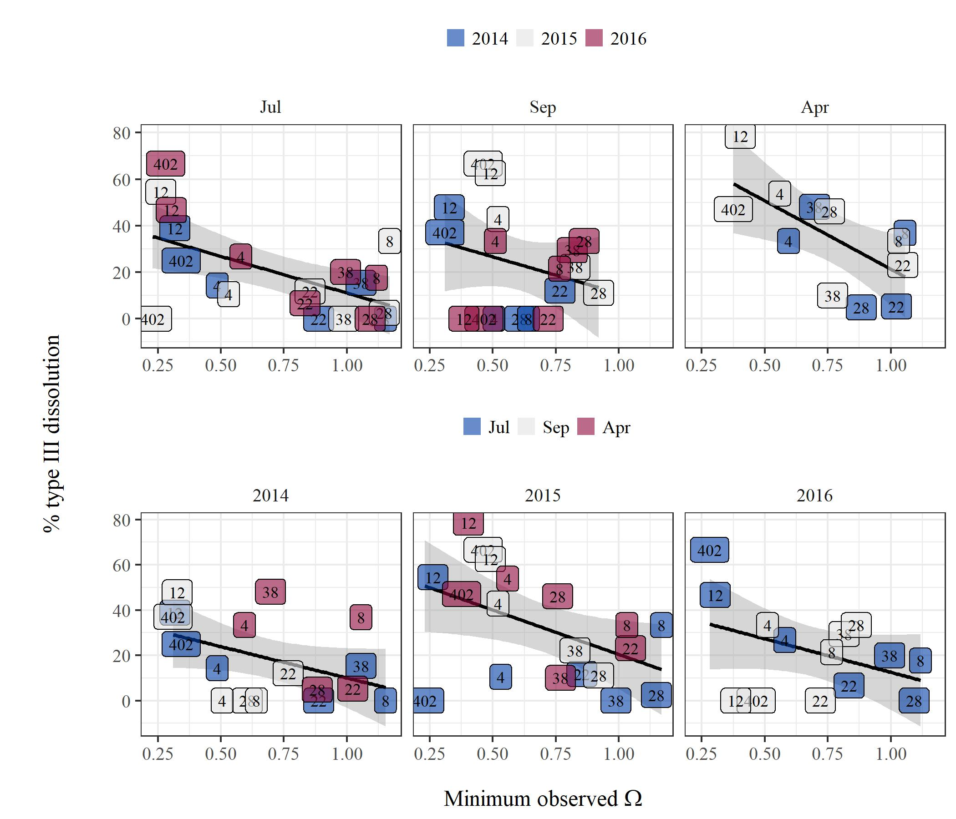

Figure 5: Percent type III dissolution measured in pteropods versus minimum observed aragonite saturation state for each station. The top row shows stations grouped by month across cohort years and the bottom row shows stations grouped by cohort years across months. Linear regression lines with 95% confidence intervals are shown in each panel.

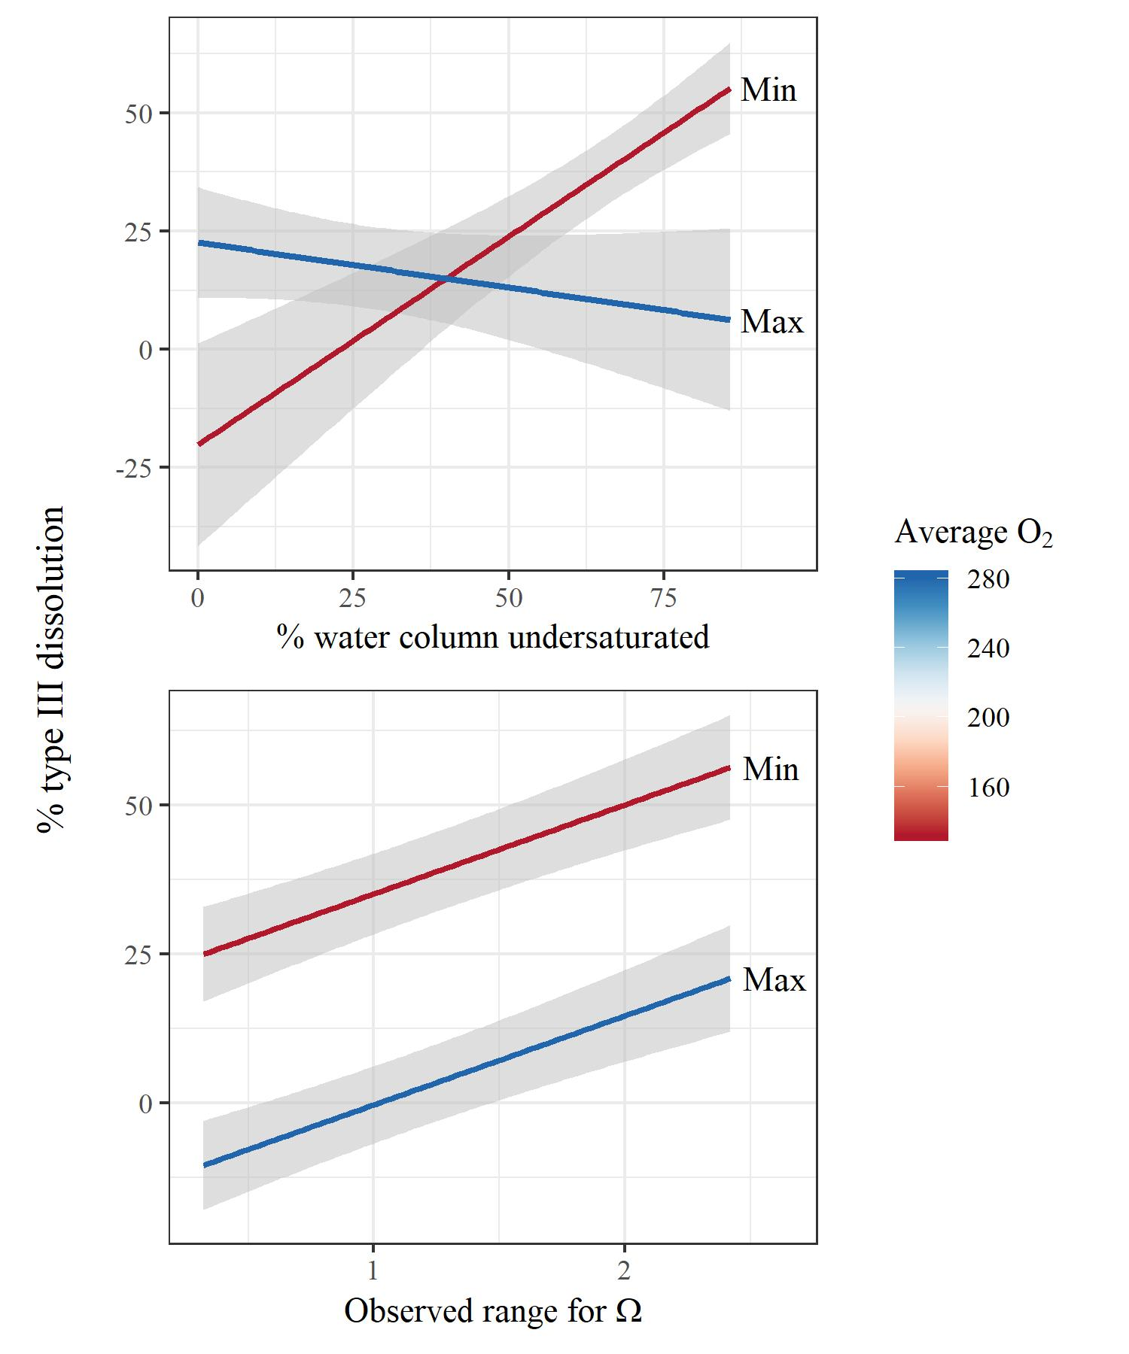

Figure 6: Interactions and additive effects of dissolved oxygen and aragonite saturation state on dissolution measures of pteropods. The top plot shows a linear model with a significant interaction between oxygen and the percentage of the water column undersaturated for aragonite, where the latter predictor had a significant main effect on dissolution. The bottom plot shows a linear model with significant main effects for both oxygen and the observed range of aragonite saturation state in the water column for each site. Each model is based on July observations across all sample years. The color range depicts the minimum and maximum observed values for average dissolved oxygen across all stations.

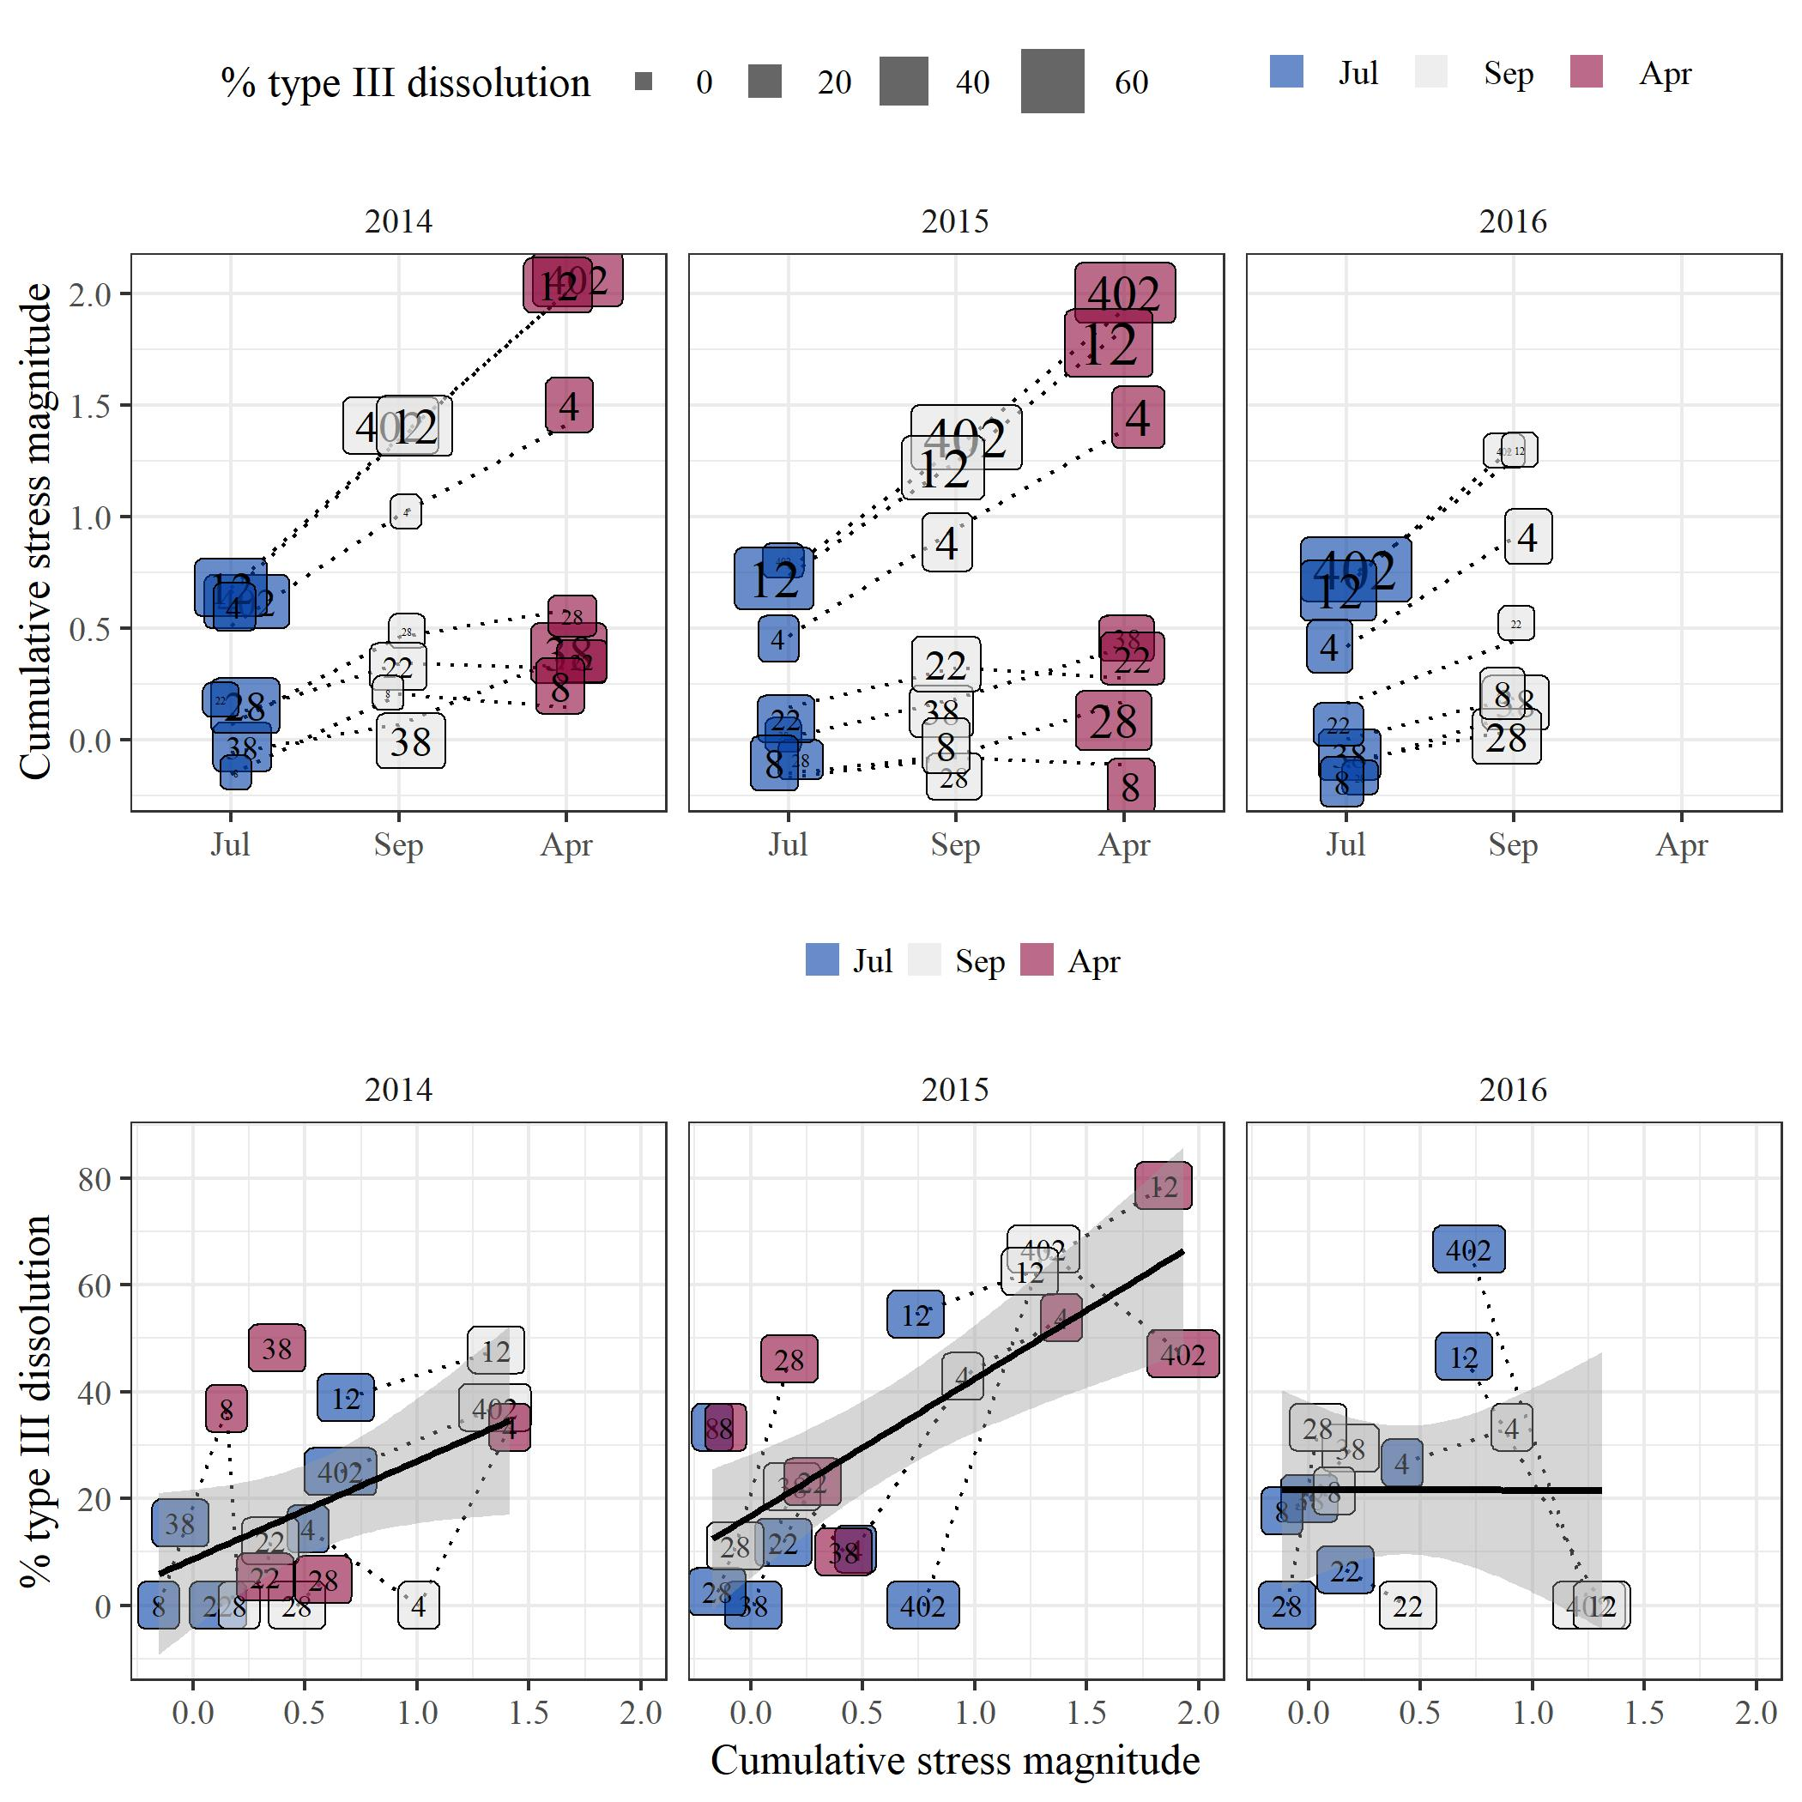

Figure 7: Relationships between percent type III dissolution and cumulative stress magnitude within cohort years. The top plot shows the progression of estimated cumulative stress from July to April throughout a cohort year for each station, with points sized by percent dissolution. The bottom plot shows the estimated linear relationship between percent dissolution and cumulative stress. The cumulative stress estimates within a year represent the frequency and magnitude of estimated exposure time of pteropods in a cohort when conditions were under-saturated below threshold .